**Marvellous Infosystems : Angular Assignment 1**

**Name: Shrirang Jagdish Nikam**

**Enrollment No: 396AM_Shrirang**

1. **Write a typescript program which contains one function named as Maximum. That function accepts three parameters and it should return largest value from three input parameters.**

**Input: 23 89 6**

**Output: Maximum number is 89**

**Answer:**

function Maximum(num1: number, num2: number, num3: number): number

{

let max = num1;

if (num2 > max) {

max = num2;

}

if (num3 > max) {

max = num3;

}

return max;

}

const num1 = 23;

const num2 = 89;

const num3 = 6;

const maxNum = Maximum(num1, num2, num3);

console.log(`Maximum number is ${maxNum}`);

**Output Screen:**

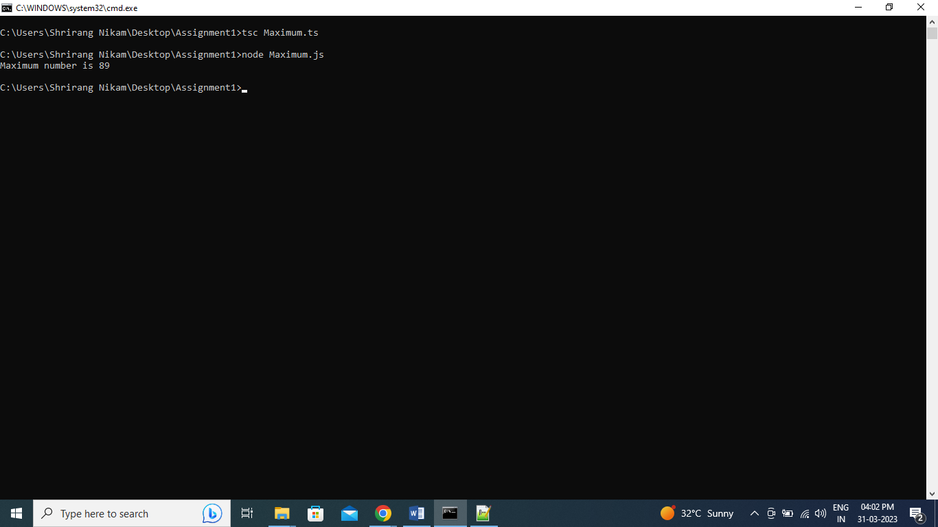

1. **Write a typescript program which contains one function named as Area. That function should calculate area of circle. Accept value of radius from user and return its Area. Default value of PI should be 3.14 if it is not provided by the caller.**

**Input: 5**

**Output: Area of circle is 78.5**

**Answer:**

function Area(radius:number,PI:number=3.14):number

{

return radius*radius*PI;

}

var CircleArea:number;

CircleArea=Area(5);

console.log("Area of circle is "+CircleArea);

**Output Screen**:

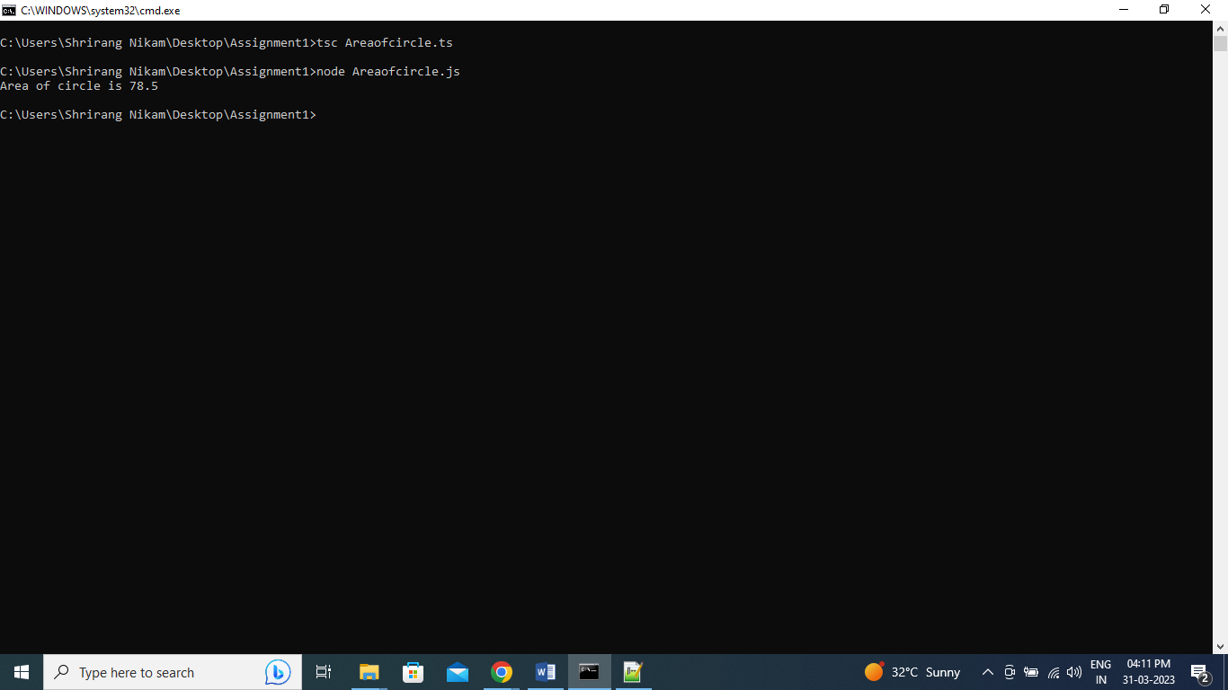

1. **Write a typescript program which contains one function named as Display Factors. That function should accept one number and display factors of that number.**

**Input: 20**

**Output: 1 2 4 5 10**

**Answer:**

function Factor(num1:number):string

{

var fact:string="";

for(var i=1;i<num1;i++)

{

if(num1 % i == 0)

{

fact=fact+" "+i;

}

}

return fact;

}

var fact:string;

fact=Factor(20);

console.log(fact);

**Output Screen:**

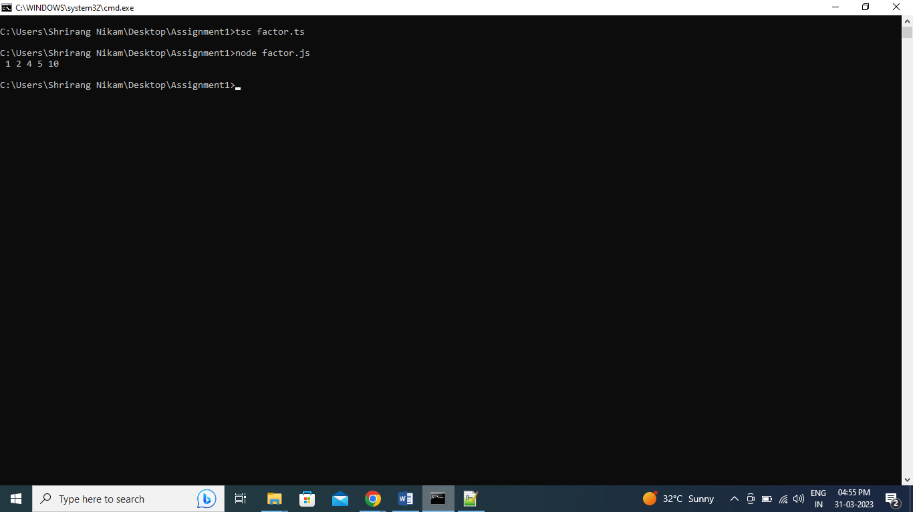

1. **Write a typescript program which contains one function named as Check Prime. That Function should accept one number and it should return true if the given number is prime and otherwise return false.**

**Input: 11**

**Output: It is prime number**

**Answer:**

function PRIME(num1:number):void

{

for(var i=2;i<num1;i++)

{

if(num1 % i == 0)

{

console.log(" It is not prime number");

return;

}

}

console.log(" It is prime number");

}

PRIME(11);

**Output Screen:**

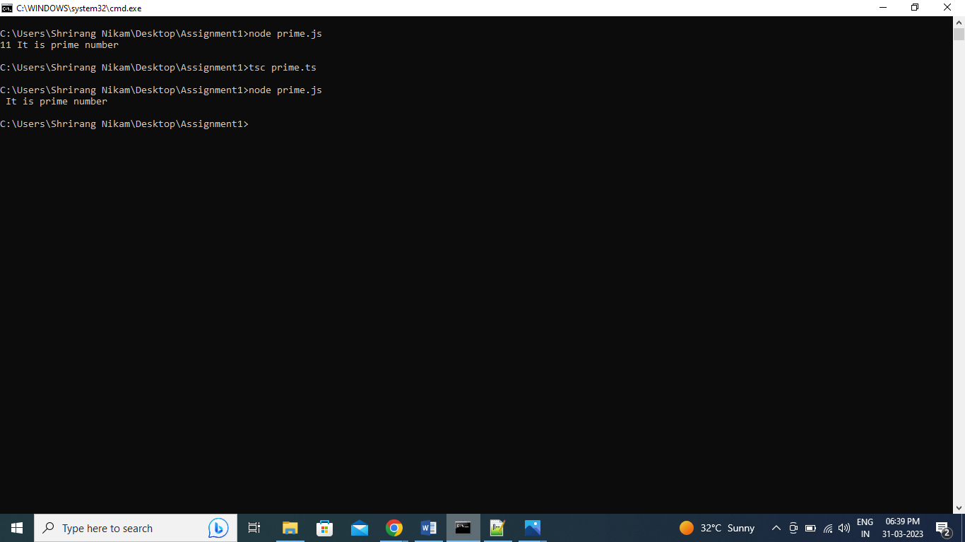

1. **Write a typescript program which contains one function named as Fibonacci. That function accept one number from user and print Fibonacci series till that number.**

**Input: 21**

**Output: 1 1 2 3 5 8 13 21**

**Answer:**

function Fibonacci(num1:number):void

{

var Fab=[];

var Fabstr:string="";

var count=1;

for(var i=0;count<num1;i++)

{

if(i==0 || i==1)

{

Fab[i]=1;

}

else

{

Fab[i]=Fab[i-1]+Fab[i-2];

count=Fab[i];

}

}

for(var j=0;j<Fab.length;j++)

{

Fabstr=Fabstr+" "+Fab[j];

}

console.log(Fabstr);

}

Fibonacci(21);

**Output Screen:**

